LAB Assignment No 4
Topic: Random Forest and Support Vector Machine Classifier
Question 1
Classify flower species using Random Forest.
Task:
- Load the Iris dataset from sklearn.datasets.
- Split into training (70%) and testing (30%) sets.
- Train a Random Forest Classifier.
- Predict flower species on the test set.
- Calculate and print model accuracy.
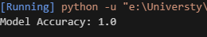
Question 2
Use SVM on Breast Cancer Dataset and Classify tumors as malignant or benign.
Task:
- Load the Breast Cancer dataset using sklearn.datasets.load_breast_cancer.
- Train an SVM classifier (use SVC(kernel='linear')).
- Evaluate the model using accuracy and confusion matrix.
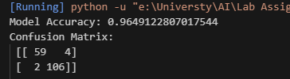

Question 3
Use Random Forest on CSV Dataset (Custom) : Predict student pass/fail based on study hours and scores.
Task:
- Load a CSV file (e.g., students.csv) with columns: study_hours, attendance, marks, result.
- Train a Random Forest Classifier to predict result (Pass/Fail).
- Display accuracy score and feature importance.
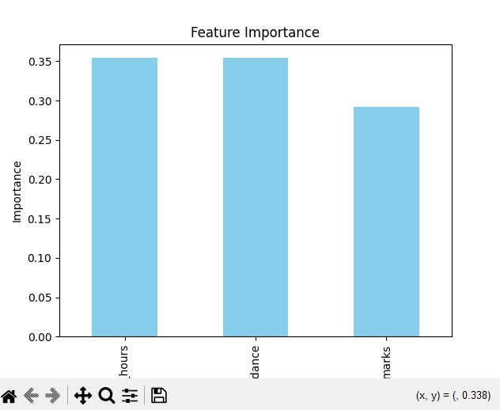
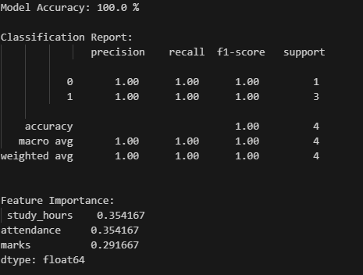

Question 4
Use SVM on Digits Dataset and to identify the: Handwritten digit recognition.
Task:
- Load the Digits dataset from sklearn.datasets.load_digits.
- Train an SVM classifier with an RBF kernel.
- Test on unseen data.
- Print accuracy and visualize some misclassified samples.
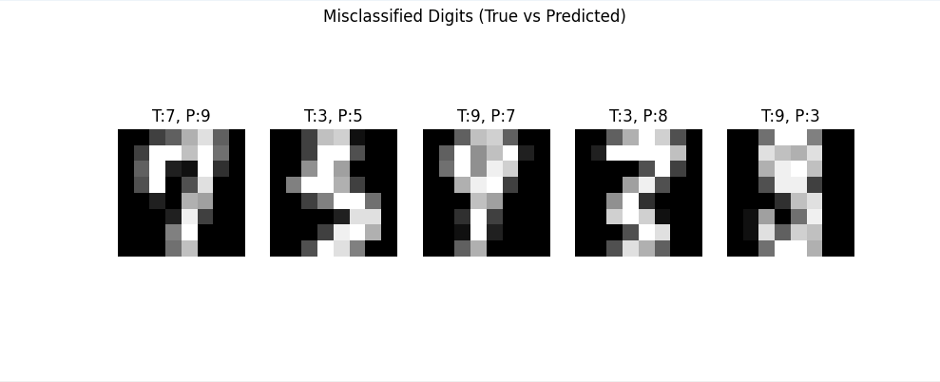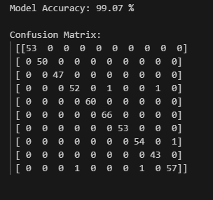

Question 5:
Compare Random Forest vs SVM on Same Dataset (you can choose any dataset): Compare two models on the same data.
Task:
- Use the Wine dataset from sklearn.datasets.load_wine.
- Train both:
RandomForestClassifier(n_estimators=100)
- SVC(kernel='rbf')
- Print accuracy of both models.
- Conclude which performs better.
